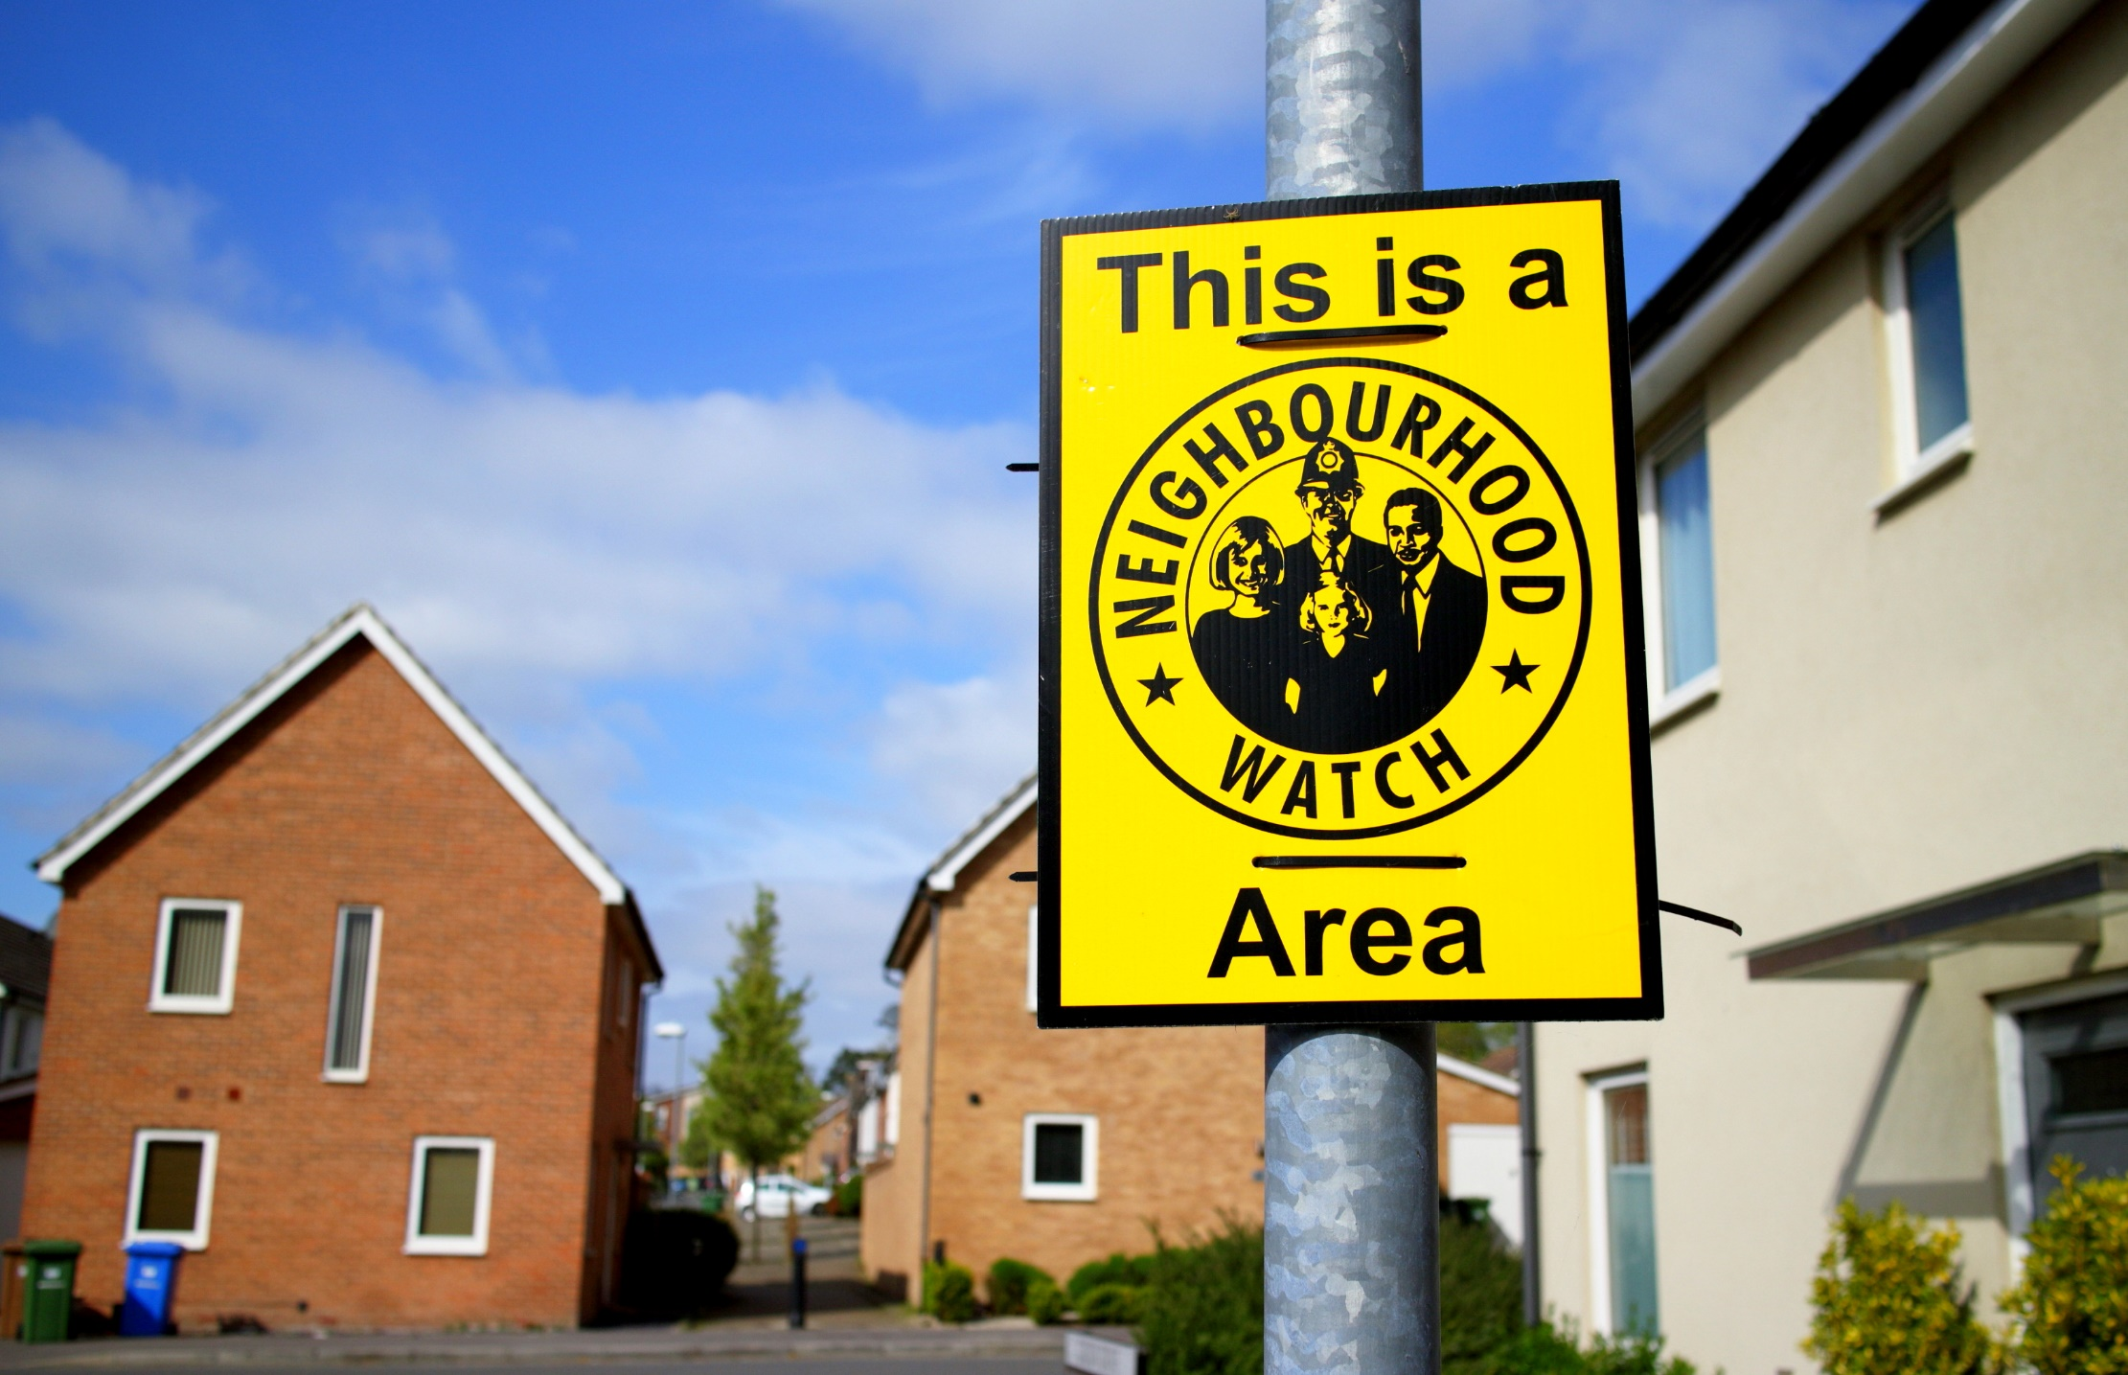

|  |
| --- |
|  |
|  |
| Last Updated: November 2024  NEIGHBOURHOOD NETWORK  Authored by: Sarah Weichardt & Lucy Carew |

TRUSTEE

RECRUITMENT

PACK

2024

|  |
| --- |
| WELCOME TO THE NEIGHBOURHOOD NETWORK We are a registered charity focusing on community safety and its links to improving health and well-being in our communities  Our Vision  Our vision is that by being a member of Neighbourhood Network, people will feel better equipped and informed to create safer environments in which to live and work improving people’s lives, health and well-being in the long term.  Our Mission  Our mission is to work with and support you to make your communities safer and healthier.  Our Aims   * To support and empower people aiming to create safer environments. * To be a support to other organisations helping communities to be more proactive in reducing crime * To be a trusted communicator and educator of key messages from Community Safety Partners * To be an introducer and facilitator of engagement between Neighbourhood Network members and community safety and health partners * To provide cost effective community safety solutions to Neighbourhood Network members and the wider public   Our Values  **Trusted** - We are dependable, caring, respectable, approachable, and supportive.  **Community focused** - We bring people together.  **Collaborative** - We work as a team, in partnerships and within communities.  **Inclusive** - We are welcoming to all people.  **Proactive** - We are active within communities, and we are relevant in today's world. About us The Neighbourhood Network is a small charity based in Hull that focuses on building safer and healthier communities in the Humber region. Recent years have seen the continued growth and success of Neighbourhood Network, initially created to support different types of organisations, charities and community groups all of whom have the common aim of improving their communities and making them safer and healthier.  We have a small team of paid staff who support and enable our 480 plus member groups and wider communities to take a positive action to make a difference within their own communities to help improve and enrich their own lives. This is not just working with communities but often involves pro-active work with statutory and voluntary  partner agencies,    The team is currently made up of three part-time employees and an apprentice with an additional Project Co-ordinator post in recruitment. The team offer support to our member groups, along with organising community engagement events, training and education, signposting, networking, one to one support, delivering community safety and health & wellbeing projects across the region.  We have three main areas of focus which are:   * Community Safety * Menopaus‘ull Support Network * Community Centre @ 87 Goodhart Road, Bransholme, Hull.   Below highlights the type of work the Neighbourhood Network team deliver   * Awareness webinars with a focus on Community Safety i.e., Fraud/Crime prevention/Neighbourhood Watch * Free Neighbourhood Watch resources i.e., signs/stickers/booklets * Supporting member groups in the creation and printing of community newsletters * Organising Neighbourhood Fun Days * Retail/Business Watches support * Humber Watch Association (regional Neighbourhood Watch steering group) * Hosting an Annual Awards Event for its members and the wider community * Victim Referral project – working with partners to support the vulnerable and victims of crime * Crime Reduction Shop – offering low-cost items to the wider public * Cycle crime prevention project – Target Hardening and Education Initiative * Menopaus’ull Support Network – Health & Wellbeing support for women going through the menopause   A picture containing outdoor, tree, person, road  Description automatically generated A group of people standing in a garden  Description automatically generated with medium confidence A group of people holding certificates  Description automatically generated with medium confidence |
| About the Board of Trustees  The Neighbourhood Network’s Board of Trustees is there to make sure the charity operates within its and the Charity Commission’s principles, is well run, and operates in ways that are lawful, safe, honest, and responsible. The Board offers guidance and expertise to the joint charity managers. Our volunteer Trustees are positive and passionate advocates for the charity’s core mission, alongside due diligence to ensure that the charity is operating fairly and in line with charity law. In legal terms the trustees take ultimate responsibility for governing the charity and how it is run.  In 2021, the charity celebrated its 10th Anniversary, welcoming, past, and present trustees, and supporters of the charity. In 2023, Neighbourhood Network also became a Charitable Incorporated Organisation (CIO) which means we are registered as such by the Charity Commission for England and Wales. It is a corporate form of business designed for charitable organisations in England and Wales. The main benefits of this status are that it allows and clearly defines the organisations and its members’ legally liabilities.  We currently have three Trustees who bring a range of related skills and experience, but we need more volunteer Trustees to help the Board better reflect the communities we serve. |

Neighbourhood Network Trustee Terms

Currently the Board of Trustees holds core meetings quarterly. These are generally scheduled on a Friday at 9.30am and meetings last around 2 hours but this can be flexible. We also have interim meetings as the business requires. All core meetings are scheduled at the end of each year for the year ahead. Trustees are responsible for decisions made by the board during their term of office, even if they are in attendance or not.

When new trustees join, the Board will work together to develop an inclusive environment, this can include organising meetings online or in-person, changing times and dates of meetings to accommodate trustees around their own personal and work commitments.

You must always put your Charity’s interests first. Trustees’ personal and professional connections can often bring benefit to the work of the charity however, these connections can give rise to conflicts of interest.

Trustees are required to complete a Conflict of Interest and a Skills Audit form on appointment and on a yearly basis to enable the charity to keep up to date with any new skills and issues which may arise. Trustees will also have the opportunity to declare any interests not recorded on the Conflict-of-Interest form but maybe associated with agenda items being considered at each meeting.

All Trustees are asked to support and/or represent the charity by attending any formal events such as our awards and promotional events. Information regarding such an event will be circulated at the earliest convenience.

Being a trustee is a *voluntary unpaid position*. The charity will reimburse travel expenses reasonably incurred in connection with any duties as agreed with the Chair.

Trustee Responsibilities include:

* Understanding the work of the charity and support its mission, vision, aims and objectives
* Reviewing the charity’s resources – funds, members, assets, reputation
* Review board reports and charity documents to actively contribute to trustee meetings
* Represent and advocate for the charity at events and meetings i.e., network events
* Have a willingness to learn and understand the roles and responsibilities of a trustee including charity policies, structures, and liabilities.

The charity commission sets out six main duties of a trustee in their ‘The Essential Trustee’ guidance document, these include:

1. Ensure your charity is carrying out its purposes for the public benefit

2. Comply with your charity’s governing document and the law

3. Act in your charity’s best interests

4. Manage your charity’s resources responsibly

5. Act with reasonable care and skill

6. Ensure your charity is accountable

The following documents provide lots of further information and guidance on the role and responsibilities of Charity Trustees.

Charity Commission’s Charity Trustee Welcome Pack [Charity trustee welcome pack - GOV.UK](https://www.gov.uk/government/publications/charity-trustee-welcome-pack/charity-trustee-welcome-pack)

To view ‘The Essential Trustee’ guide, click on the link below.

The essential trustee: what you need to know, what you need to do (CC3) - GOV.UK (www.gov.uk)

*Who are we looking for?*

The Neighbourhood Network wants to recruit a Board of Trustees with a diverse set of skills and voices that represent the communities our charity serves, and both supports and challenges the charity to be the best it can be. The work of a Trustee is extremely rewarding.

We are looking for people who are committed to:

* Supporting the charity to thrive as a key part of the future development of the Hull and Humber area’s future development
* Understanding and responding to change
* Inclusion and diversity

We would like to hear from people with experience or skills in the following areas:

* Accountancy
* Law
* Business
* Health and Wellbeing
* Community Engagement
* Public Services

What happens Next?

**How to Apply:** If you are interested in becoming a Trustee at Neighbourhood Network, please send your CV and a cover letter outlining your interest and suitability for the role to [sarah@nnetwork.org.uk](mailto:sarah@nnetwork.org.uk) or call 01482 826061.

Upon receipt of your CV you will be sent a pack which includes an ‘Expression of Interest - New Trustee Form’ which you should complete and return to us.

If your application has been shortlisted, you will be contacted and arrangements made for you to meet the existing Trustees for interview. If you are successful, your appointment needs to be formally accepted at the next Trustee Meeting. You will be kept informed at all times and we wish you success.

To apply, email [sarah@nnetwork.org.uk](mailto:sarah@nnetwork.org.uk)

*“What would we do without your help and advice, thanks so much”* Berkeley Street Neighbourhood Watch