Email: CIACHumber@gmail.com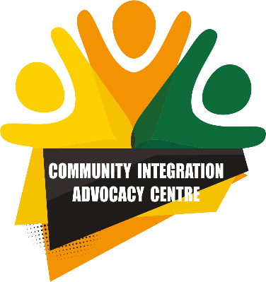

CIAC

185 Ferensway

Hull

HU1 3UA

**Engagement Worker/Kompasi Coordinator: Job Description**

CIAC Mission: Supporting emerging communities to contribute fully to life in the UK as committed and active citizens.

Community Integration and Advocacy Centre (CIAC) is a Charitable Incorporated Organisation registered with the Charity Commission.

**Engagement Worker/Kompasi Coordinator: employment details**

Full Time: 37.5 hours per week (0.4 FTE Kompasi Coordinator)

Specific times of operation: 9:00 am to 5:00 pm Monday to Friday (may be required to work outside these times to meet deadlines with time off in lieu)

Salary level: £25,480 p.a.

Pension: NEST with 3% employer contribution.

Annual leave: 30 days p.a. rising by one day p.a. until reaching 35 days p.a.

Long service bonus annual leave: following ten years continuous employment with CIAC an additional twenty days annual leave will be added for that year.

Start date: ASAP

Contract length: initial six months probation with role funded for one year.

Funded by: Disrupt Foundation (0.4 FTE); The Fore (0.4 FTE) and CIAC (0.2 FTE)

Reporting to: Chief Executive Officer/Principal Immigration Advisor (CEO/PIA)

Location: multiple locations across the Humber region with some travel to West Yorkshire.

**Employment role:**

Engagement Worker (0.6 FTE)

The Engagement Worker (EW) will be supporting the development of multi stakeholder engagement through a variety of feedback mechanisms alongside supporting the CEO with the development of a range of documents requiring research skills. The funding for this role covers three separate sources of funding. Dependent on the success of future funding bids, the intention is for this role to continue beyond the initial year.

Kompasi Coordinator role (0.4 FTE)

[www.kompasi.org](http://www.kompasi.org) was launched in June 2024 to support the local migrant justice network with signposting and referrals to connect people with the support they need. In 2025 Kompasi will extend into West Yorkshire and the Humber in partnership with CIAC, Leeds Refugee Forum and the Manuel Bravo Project. Local support and coordination are needed to shape the tool for organisations in the region, maximise its use and keep it relevant and updated.

**Duties and Responsibilities**

* Relationship building and information gathering with organisations that support refugees, asylum seekers and migrants across the Humber and Yorkshire which may involve regular travel to and working from the offices of different partners.
* Establishing and maintaining CIAC’s user and stakeholder engagement mechanisms.
* Establishing and maintaining user focus groups to engage in research and feedback.
* Compiling case studies to support awareness raising.
* Developing a needs assessment document through mapping services and analysing gaps in provision across the Humber region.
* Initial work on a scoping document to establish a collaborative research network with the intention of resourcing significant funding for research into migrant destitution across the Humber region.
* Supporting the CEO/Principal Immigration Advisor with policy work in preparation for SQM/LEXCEL/Trusted Charities/Advice Quality Standards accreditation.
* Any other reasonable tasks as required.

Kompasi specific duties and responsibilities

* Managing the administrative, back-end, of Kompasi e.g. updating service information, supporting members with accounts and log-ins, functionality and capacity updates.
* Work with Kompasi’s national lead on the continued testing and embedding process to ensure it is updated based on feedback and easy to use.
* Internal and external communications to ensure information, updates and feedback are collected and shared in a timely and accessible manner.
* Support partner organisations to receive relevant technical and compliance training for the tool including GDPR and safeguarding training.

**Criteria**

**Essential Experience:**

* Experience of working with multiple stakeholders to deliver projects
* Experience of providing information to stakeholders in a useful format.
* Knowledge and awareness of the Humber refugee and asylum seeker sector
* Understanding of and commitment to the vision, mission, values and objectives of Kompasi and CIAC
* A demonstrable commitment to and understanding of equalities, diversity and inclusion and a commitment to anti-racism

**Essential Skills**

* Demonstrable administrative competency and IT literacy
* Strong communication skills: written and verbal in English
* Excellent interpersonal skills including the ability to effectively communicate, network and negotiate with people from a wide range of backgrounds
* Organisational, administrative and time management skills, with the ability to prioritise tasks and deliver/produce work under pressure and to deadlines.
* Effectively operate within organisational policies and procedures.

**Desirable Experience and Skills**

* Direct experience of the asylum or immigration system – either through working in the sector or lived experience.
* Experience with complex data and information management (for example monitoring databases, MEL etc.)
* Experience in a communications role or similar
* An understanding of health and safety along with safeguarding and Data Protection
* Facilitation skills to enable effective discussions

A full, clean driving licence and access to a car are required as travel across the Humber region will be required.

CIAC is an equal opportunities employer and seeks to make all reasonable adjustments to this role as is feasible.