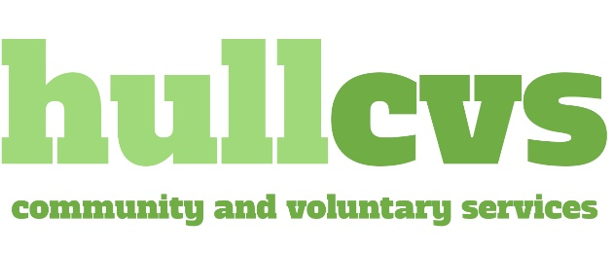

Head of Development
Hull CVS are currently looking for an exceptional individual to join our senior leadership team in a brand new and unique role. The post holder will have insight and involvement across our whole Group’s operations, and so we’re looking for an excellent all rounder who has the ability to work on both internal operational functions, as well as external service delivery.
The ideal candidate will be comfortable working at pace across a number of areas, and be able to thrive in being assigned to different projects at short notice. We’re looking for someone who can juggle multiple roles, tackle new challenges daily, and be a solid, dependable source of support to the Chief Executive. The postholder will be altruistic by nature; have excellent communication and partnership development skills; and be a creative thinker who is able to convey ideas into credible bids and proposals.
About Us
Hull CVS is a registered charity, established over 40 years ago to support local charities and causes. We are at the forefront of sector development, community empowerment and volunteering initiatives in Hull. Through our subsidiary, Meeting New Horizons, we extend our reach across the wider Yorkshire and Humber region, ensuring that our community projects positively impact more lives.

At our core, we aim to empower local communities by supporting wider Voluntary, Community & Social Enterprise (VCSE) organisations; by mobilising the power of volunteering; and by giving people a greater voice in the services they use. We have a clear set of aims and work with a variety of funders and stakeholders across a wide range of issues and needs.

As a Group we have achieved consistent growth and stability, and for several years have invested our own funds into projects that further benefit the groups and communities we exist to serve. We also understand the importance of investing in our employees' growth and are always seeking opportunities to further progress and develop our employees.

When you join our team, you're not just an employee – you become part of a community where everyone is passionate about making a difference. We prioritise creating an environment where our staff not only care for our beneficiaries but also support each other.

What we offer:
- £38,000-£40,000 per annum salary.
- 25 days holiday plus public holidays, with an additional 3 days to be taken over Christmas after 1 years’ service.
- 35 hour full time working hours – offering excellent work life balance.
- Tailored Training and Induction programme covering all areas of current work.
- Company Health plan after completion of probationary period.
- Access to our Employee Assistance Programme with free telephone counselling service.
- Organisation wide away days.
- Career development pathways.
- A fun and nurturing working environment.

For more information about the role, please view the job description and person specification on our website.

**Please note that due to the demands of this role it is a full time position, preferably worked over 5 days Monday to Friday, or at a minimum of 4 days between Monday and Friday.**

For an informal chat about the position, please contact Helen Grimwood, Chief Executive at hgrimwood@hull-cvs.co.uk or call 07480 795548.

To apply for the position, please send a CV and covering letter outlining how you meet the requirements of the role to Helen Grimwood at hgrimwood@hull-cvs.co.uk

PLEASE NOTE – applications without a cover letter will not be considered.

Closing date: Sunday 3rd November 2024
Interview Date: Provisionally Wednesday 13th November 2024

