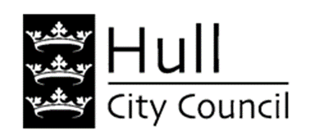

Resident Engagement

Hull City Council is working with a local charity to find out how people in supported accommodation feel about the support they receive.

**What is it about?** We want to know what good support looks like, and what people with lived experience of supported accommodation think about the help they get. We are hoping to find this out through focus groups, which means getting small groups of people together in a safe space to talk.

**Who is it for?** Anyone who lives in, or has recently lived in, non-contracted supported housing. This means living in accommodation provided by organisations that receive enhanced housing benefit on behalf of their tenants. If you aren’t sure if this applies to you, don’t worry – just contact us.

**How long will it take?** Each focus group will last about 2 hours, and you only have to attend one.

**Why should I take part?** You will be helping to set out what good support looks like, and this information will be shared with the UK Government when they bring in new laws and guidance on supported accommodation. We will provide lunch at each session, and a £15 shopping voucher for everyone who takes part. We can also help with transport. If you would like help to get there, please call Pippa Robson on 07791 040433, or talk to your support worker.

**When and where?** We are holding groups on different dates in August and September, in a confidential space at Princes Quay Shopping Centre.

**How do I take part?** For more information, or to tell us you would like to attend a group, please call Pippa Robson on 07791 040433 or email pippa@nbforum.org.uk