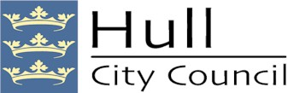

Hull City Council
Community Asset Transfer Guide

Contents:

- What is a Community Asset Transfer?
- Background to Community Asset Transfers: National Policy Context
- Purpose of the Policy
- How can Hull City Council assist with a Community Asset Transfer?
- Legal Framework and Enabling Powers
- Organisations Eligible for Community Asset Transfer
- How to identify Assets which are suitable for Community Asset Transfer
- Community Asset Transfer Process
  - Initial Engagement with Sector Connect
  - Expression of Interest, Community Engagement and Health Check
  - Full Application and Business Plan
  - Business Plan Review
  - Approvals Process
  - Heads of Terms and Service Level Agreement
  - Appeals
- Timescales
- Support and Advice
- Contact Details / Appendix

- What is a Community Asset Transfer (CAT)?
A Community Asset Transfer is the transfer of management and/or ownership of public land and/or buildings to a community organisation, usually at less than market value to achieve an economic, social and/or environmental benefit.

- Background to Community Asset Transfers: National Policy Context
In 2006, the Local Government White Paper –“Strong and Prosperous Communities” introduced a new approach to managing public sector assets and delivering public services. It gave Councils greater freedom to work with other public sector providers, third sector organisations and local people and explored the opportunities for communities to manage and own local land and property assets.
The publication of the 2007 Quirk Review – “Community Management and Ownership of Public Assets” further promoted this new attitude to delivering community assets and services by investigating options of increased community management and ownership of assets. In particular, it looked at ways to overcome potential barriers to asset transfer and ways to manage and minimize associated risks.
A number of subsequent Government documents have further recognised the significant potential benefits that may be realised through Councils creating and supporting community partnerships. The Localism Act (2011) devolved decision making powers to neighbourhood level and advocates new rights and powers for communities and individuals such as the “Community Right to Challenge” and “Community Right to Bid”.
There is now high-level support and recognition from Government that asset transfers can create more confident and empowered communities and increase the number of sustainable community/third sector groups. The Government wishes to see Local Authorities empowering local people and organisations to transform land and buildings into vibrant community spaces and support a thriving third sector.

- Purpose of the Policy:
The purpose and intent of the Community Asset Transfer was approved by Hull City Council’s Cabinet on 26th September 2022 as a response to the Governments requirements.
The purpose of the policy is to empower communities through ownership and for the transfer of Council assets to be determined through a clear, fair and transparent process of evaluation.
The Community Asset Transfer policy will support the Councils Community Plan, which was approved by the Full Council on the 16th November 2023, and work within the agreed ambitions and commitments set out within the Plan, and which form the key areas of focus for the Council, and is partners, over the next decade.
The ambitions identified include;
- Safe and Welcoming Neighbourhoods
- A Healthier and Fairer Hull
- Reaching our potential
- Economic Growth that works for all
- Our Culture, Our Heritage,
The commitments identified include;
- Engagement of all residents and communities
- Strong, united leadership committed to improving outcomes
- A focus on inclusion.
Community Asset Transfer (CAT) is therefore not just about the transfer of land, buildings and structures; but rather it is part of a wider picture in helping Communities meet their shared aspirations, visions and needs. It is about helping and empowering Communities to make the best use of their local assets to become resilient, entrepreneurial and to thrive in a challenging fiscal climate where the capacity for Councils to continue to deliver services in the traditional manner becomes challenging.
The CAT policy has been developed in consultation with Sector Connect, Forum CIO and Hull City Councils, Community Managers and Area Teams who deal with the wider VCSE and 3rd sector communities on a regular basis.
The policy support documents (annexed to this Transfer Guide) clearly set out the process of the CAT. This process will be reviewed periodically to ensure it is working effectively for both the Council and the VCSE community.
An annual report will also be presented to the Area Committees on the number of CAT’s processed, detailing the collective social value impact and savings to the Council. The annual report will also give an overview of the collective benefits recognised through the CAT Service Level Agreements and identify areas to strengthen the CAT policy going forward.

- How can Hull City Council assist with a Community Asset Transfer?
In respect of public land and/or buildings within its ownership, Hull City Council can offer varying lengths of Community Asset Transfers, between 3-99 years, depending on the request and requirements of the organisation, their ability to evidence the governance and finance to manage the building and the social value of the projected activities.
There are five key issues to consider and /or addressing when looking at a Community Asset Transfer:
- Is your organisation ready for an asset transfer?
- Have you identified an appropriate asset and gained a full understanding of the requirements of managing, operating and maintaining it?
- Is the identified asset owned by Hull City Council?
- Do you have a plan for how you will generate enough income to meet the running costs of the asset both in the short and long term?
- Does your organisation deliver a service that meets the needs of the Council and local and wider communities, that are not currently being met through its own or alternative providers in the city?

- Legal Framework and Enabling Powers
Section 123 of the Local Government Act 1972 requires that all disposals are to be at the best consideration reasonably obtainable under the circumstances. This applies to the disposal of any interest in land and property. However, this was subsequently amended under the Local Government Act 1972 General Disposal Consent Order (England) 2003.
The Order gave Council’s wider powers to dispose of land and property assets at less than market value where it could be demonstrated that they promoted the economic, social and environmental well-being of the area; and provided that the unrestricted undervalue of the asset to be disposed of and the consideration for the disposal does not exceed £2,000,000. (Two million pounds).

- Organisations Eligible for Community Asset Transfer
Applications for a CAT will be considered from community and voluntary sector groups and other third sector not for profit organisations.
All applicant groups or organisations should be able to demonstrate good governance and an appropriate legal structure.
The Applicant must:
- Be non-profit distributing – i.e. no applications will be accepted from private companies, private individuals or other organisations that do not fulfil this criterion. (Note: Any applicants that are profit making must reinvest any surpluses to further its social aims/community benefits).

- Be a community or voluntary sector organisation – i.e. it must be a legal entity which is non-governmental or part of the private sector.

- Exist for community, social and/or environmental benefit of the community.

- Be appropriately constituted – i.e., a registered charity, a community interest company or a charitable incorporated organisation, a not-for-profit company or co-operative. Such constitutions which can allow for the management/ownership of buildings and/or provision of services.

- Demonstrate good self-governance – i.e., by operating through open and accountable co-operative processes or set of rules, with adequate monitoring, evaluation and financial management systems and be able to provide copies of the accounts of the organisation on request. They must be truly independent in determining their own course.

- Have well defined community benefit objectives – i.e., can demonstrate that it has the skills and capacity within, or available to its managing body, to effectively deliver services and manage the asset.

- Have experience and knowledge of property management – i.e., can demonstrate that it understands Health and Safety Regulations and compliance with legislative /statutory requirements arising from ownership or management of the asset (including R&M, insurance requirements, testing, keeping of Property Records, etc.).

- Demonstrate community engagement – i.e., by proactive involvement in economic, environmental or social regeneration in Hull and / or by providing a service of community benefit in line with the Council’s strategic objectives. The Applicant must also provide evidence of the need and demand for the activities being proposed within the local community.

- Prove community cohesion – i.e. embrace diversity and work to improve community cohesion and reduce inequalities. The proposed use will ensure extensive reach in to the local community and will be open to all. (Note: Unless the Group or Organisation target and work with a specific group with the community (i.e., BAME / women / men / children, etc.). In which case further information will need to be provided as to reasons for exemption).

- Demonstrate economic sustainability – i.e. establish how the proposed use can maximise opportunities to ensure sustainability, for example through income generation, social enterprise and the hiring of space and facilities.

- Be Non-political i.e. is not engaged in supporting candidates for political office

- Voluntary i.e. there is an element of involvement of volunteers (Note: Some voluntary and community organisations appear to be entirely reliant on paid staff who may manage the volunteers whereas other organisations only operate with paid staff meaning their trustees or committee members are in fact their only volunteers)

- How to identify Assets which are suitable for Community Asset Transfer
Assets Suitable for Community Asset Transfer:
To qualify for consideration as potential CAT any asset must be in the freehold ownership of the Council and should assist in delivering the Corporate aims of the Council including the following:
• Ownership – An asset is either land or buildings or both in the ownership, or under control of the Council. (Note: The policy does not specifically include or exclude any type of asset from potential transfer to a community organisation. This enables each case to be considered on its own merits).
• Proposed Use – The asset will assist the applicant in delivering the core purpose and corporate outcomes of the Council.
• Service Delivery – An asset that is not currently required or used for direct service delivery will be considered for transfer.
Assets that are to be Excluded and Not Suitable for Community Asset Transfer:
The Council will not support the transfer of an asset transfer if any of the following apply:
• Service delivery – the asset is required for service delivery or has been identified for future service delivery by the Council.
• Capital receipt or revenue income – the asset has been identified within the capital receipts programme, the asset is held for revenue income, the asset is held for long term future capital appreciation or the estimated capital receipt from the asset could contribute to the overall capital receipts programme.
• Opportunity costs – any asset where the Market Value or Development Value is greater than its existing use value at the time of the application, will be excluded from the Community Asset Transfer policy. (Note: This applies to assets on their own or where they form part of an amalgamated site).
• Housing development – any asset that can contribute to the Council’s housing development programme.
• Assets that are not fit for purpose and/or require significant investment will generally be excluded from the policy. (Note: Exceptions may be made where the community organisations can secure the financial resources available to bring the property back into a state of repair).
• Part of the Asset - the Council reserves the right to exclude Community Asset Transfer where the proposal only relates to part of an asset.
• Historic parks, public parks and playgrounds and any other open spaces as identified in the Local Plan are excluded.
Hull City Council will, wherever possible, provide a Property Information Pack for any suitable asset identified to assist any Community Asset Transfer application which may include internal layout plans, Statutory Certification (Electrical, Gas, Legionella, etc.), Asbestos Reports, Energy Performance Certificate, etc. (Note: Exceptions may exist on the grounds of protecting personal data or commercial sensitivity)

- Community Asset Transfer Process

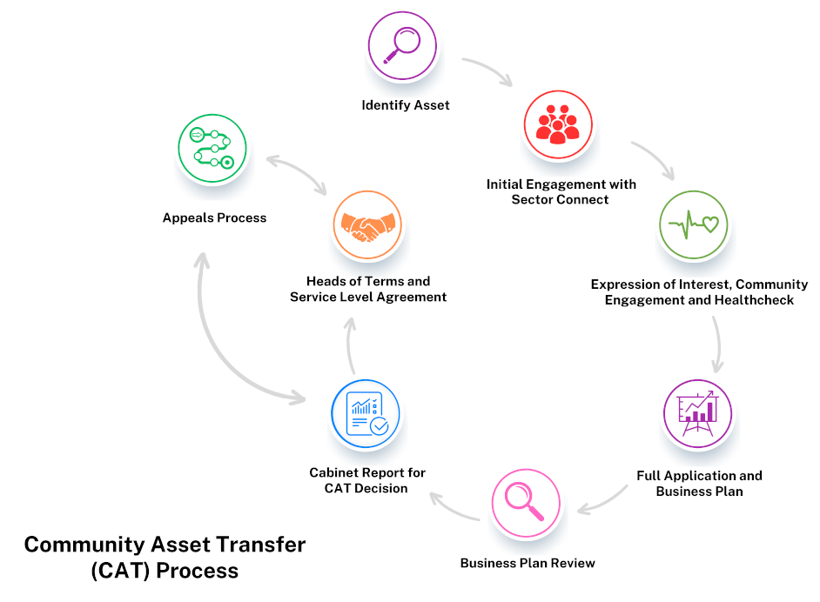

- Timescales
The CAT process is not necessarily a quick process. It is important to get it correct to ensure that all parties benefit from the Transfer. The timescales set out in the Table below, are indicative and for guidance only.
It is expected that timescales will vary in respect of each individual application and will be dependent upon such factors as, the requested information being already available, preparing several of the requested documents concurrently and the dates and lead in times to the next available Hull City Council Cabinet meeting, according to the Executive Committee Schedule., etc.
Stage | Process | Timescales  (Approx) | Lead(s)
Stage 1 | Initial Engagement | Within 1 month | Sector Connect
Stage 2 | Expression of Interest  Community Engagement Healthcheck  Review | Submitted and reviewed within 3 months | Applicant  Sector Connect  Hull City Council - Neighbourhood Coordinator  CAT Working Group.
Stage 3 | Full Application / Business Plan | Submitted within 6 months | Applicant  Sector Connect
Stage 4 | Business Plan Review | Review within 1 month | Hull City Council -  CAT Working Group  Neighbourhood and Housing  Sector Connect
Stage 5 | Cabinet Report / CAT decision | Next Forward Plan and Cabinet date available (see CMIS for dates) | Hull City Council
Stage 6 | Head of Terms  Service Level Agreement  Handover | Within 3 months | Hull City Council -  CAT Working Group  Property & Assets  Neighbourhood and Housing  Applicant
Stage 7 | Appeals Process | Reviewed within 1 month | Applicant  Hull City Council

- Support and Advice
Sector Connect will act as the initial point of contact for all community transfer groups and offer guidance throughout the CAT process. They will:
• clearly present options for the community group and keep them informed and updated of any developments. They may have to have honest and, at times, robust conversations, as required.
• advise groups on community engagement methods, business planning, governance and help generally build capacity
• signpost community groups towards written support and advice, providing templates and good practice examples for business plans or asset management plans
• provide links to other local/national agencies and intermediaries who can also offer support in some of these areas.
• work with the Board / Trustees of the community group to understand the vision / aspiration
• discuss with the Board their capacity to take forward the CAT requirements and assist in identifying any widening of the skills set within the board that may be required
• work to develop the skills and capacity of the Board
• will make introductions to the appropriate Neighbourhood Coordinator
The Neighbourhood Coordinator will provide a single point of contact for community transfer groups to help navigate the Council requirements and advise on community consultation. The Neighbourhood Coordinator will work with wider Council colleagues to coordinate the support the group may require at different stages in the process. They will:
• work with the Council’s Property and Assets team to provide information, advice and support to community groups considering CAT.
• assist community groups to navigate the Council and partners, in relation to:
- linking the community group with the appropriate service area
- community consultation.
Contact Details:
Sector Connect:
help@sectorconnecthull.org.uk
Tel. No. 01482 324474, or 01482 499030
Hull City Council
Tel. No. 01482 300300

Appendix:
- Expression of Interest
- Healthcheck
- Community Consultation Guidance
- Business Plan Template

